
INSET FOR CLASSICS TEACHERS
Monday 29th July – Friday 2nd August 2024
Stamford School
Stamford, Lincolnshire, PE9 2LL

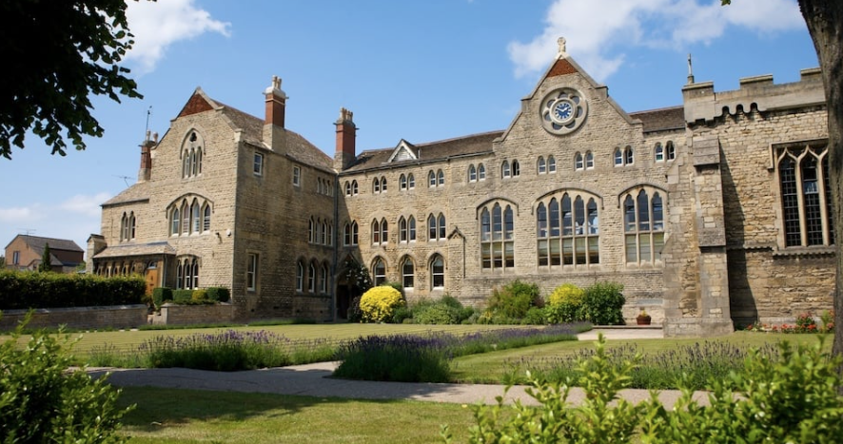
Run by practising teachers for practising teachers
Generously supported by the Classical Association
ARLT Registered Charity no. 275052
101st SUMMER SCHOOL
Tuition can be arranged for teachers who would like help with basic translation of set texts. Please ask for more information.

OPTION GROUPS

- GCSE, AS and A Level set texts for Latin, Greek and Classical Civilisation
- KS3 teaching resources
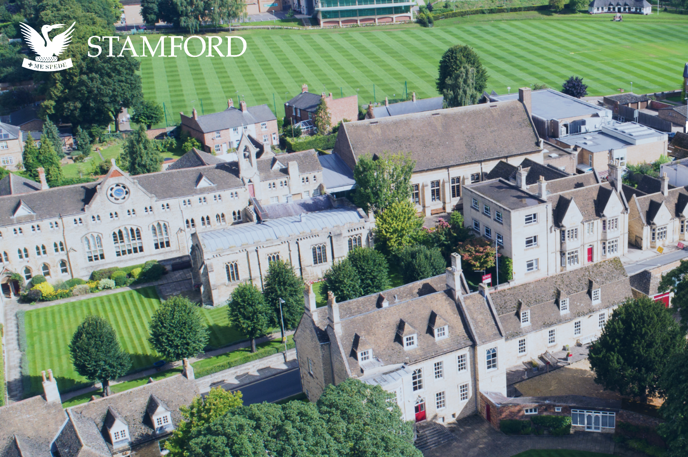
- Latin language tuition at varied levels
- Latin composition for beginners
- Spoken Latin
- Lectures on a variety of topics in Ancient Literature and History

The venue
Stamford School is located in the beautiful market town of Stamford and is a short walk from the city centre. Accommodation is mostly in single study bedrooms. Shared accommodation is available if required.

Stamford
Stamford lies close to the A1 on the edge of Lincolnshire, Rutland, Cambridgeshire and Northamptonshire. Peterborough is the nearest mainline station and has direct links to all parts of England and Scotland (Less than 1 hour to London). Stamford also has its own train station, there is a branch-line service to and from Peterborough, Birmingham and Stansted.

Excursion
Included in the cost of the Summer School is an excursion to Flag Fen, the Bronze Age Archaeological Site near Peterborough.

Speakers will include:

Professor Stephen Heyworth (Oxford University) on Ovid’s Fasti and the Roman calendar
Jim Irvine (local farmer) on the discovery of the Ketton Roman Villa, near Stamford
Angela Cheetham (Bedford Modern School) on the de Romanis course
Sebastian Hyams (Oxford University) on Ovid’s Double Heroides
Laila Tims (Hands Up Education) on the Suburani course
Caroline Bristow (Cambridge Schools Classics Project) on the Cambridge Latin Course 5th Edition
Hannah Watkins (The Learning Adventure), Classics Trip Specialist
Gráinne Cassidy (Education Co-ordinator, The Classical Association) will also be in attendance

The cost …
- should be met from your school’s INSET budget
- is halved for PGCE students
- is reduced for those attending for the first time
- includes membership of the ARLT until 31st December 2027
NB Other bursaries are available on application – please see note below*
The price per person for residents includes tuition, full board and accommodation.
- Total cost – single or shared room £285
- First time attendees: £185
- Non-residential discounted rate: £120
- PGCE Students: £145
- Daily Rate, non-residential: £35
- The cost includes membership of ARLT until December 2027
*If you wish to apply for a £100 bursary, please do so as early as possible by sending a letter from your Headteacher or a description of your circumstances in support of your application to: Dr Jessica Dixon, Hon. Treasurer arlttreasurer@outlook.com

Please go to www.arlt.co.uk to book online. Alternatively, complete this form and send to the Summer School Secretary: Alison Henshaw, 1 Quaker Close, Melbourne, Derbyshire DE73 8GW. arltsssec@gmail.com.

* Indicates a required field
§ Please provide details you check regularly as some correspondence is likely to take place outside term time
Name*
Address*
School
§ Phone* |  | § Email*
NB Personal details are retained for membership purposes and to inform you of future ARLT events and selected news items. See https://www.arlt.co.uk/privacy-policy/ for details.
Please tick here if you do not want these details to be circulated to other Summer School delegates.
Please tick here if you do not want these details to be held by the ARLT and used to contact you about future events

Accommodation* | Please tick to indicate your chosen option below:
Accommodation* | Single room: £285 |  |  |  | Non-residential: £120
Accommodation* | Shared room: £285 |  |  |  | PGCE Student: £145
Accommodation* | Name of person sharing ………………………………….. |  |  |  | First time attendee: £185
Accommodation* | Daily rate (non-residential): £35 |  |  |  | Please indicate days of attendance:
Accommodation* |  |  |  |  | Mon | Tues | Weds | Thurs | Fri
Payment* | BACS: |  |  |  | Paypal
Please enclose a deposit of £50 (non-refundable) either by PayPal when you book through the website or by BACs transfer, account name ARLT, Bank RBS, sort code 16-26-32, account no. 11137895. As a payment reference, please use surnameinitialSS24.
Balance due by 12th June by BACs transfer. If you need an alternative method of payment please contact the Treasurer arlttreasurer@outlook.com
For any other information, contact this year’s Summer School Director:
Alex Smith, adsmith@ses.lincs.sch.uk

